Automating Employee data
Upload Dataset
Viewing Overview of projects using Charts

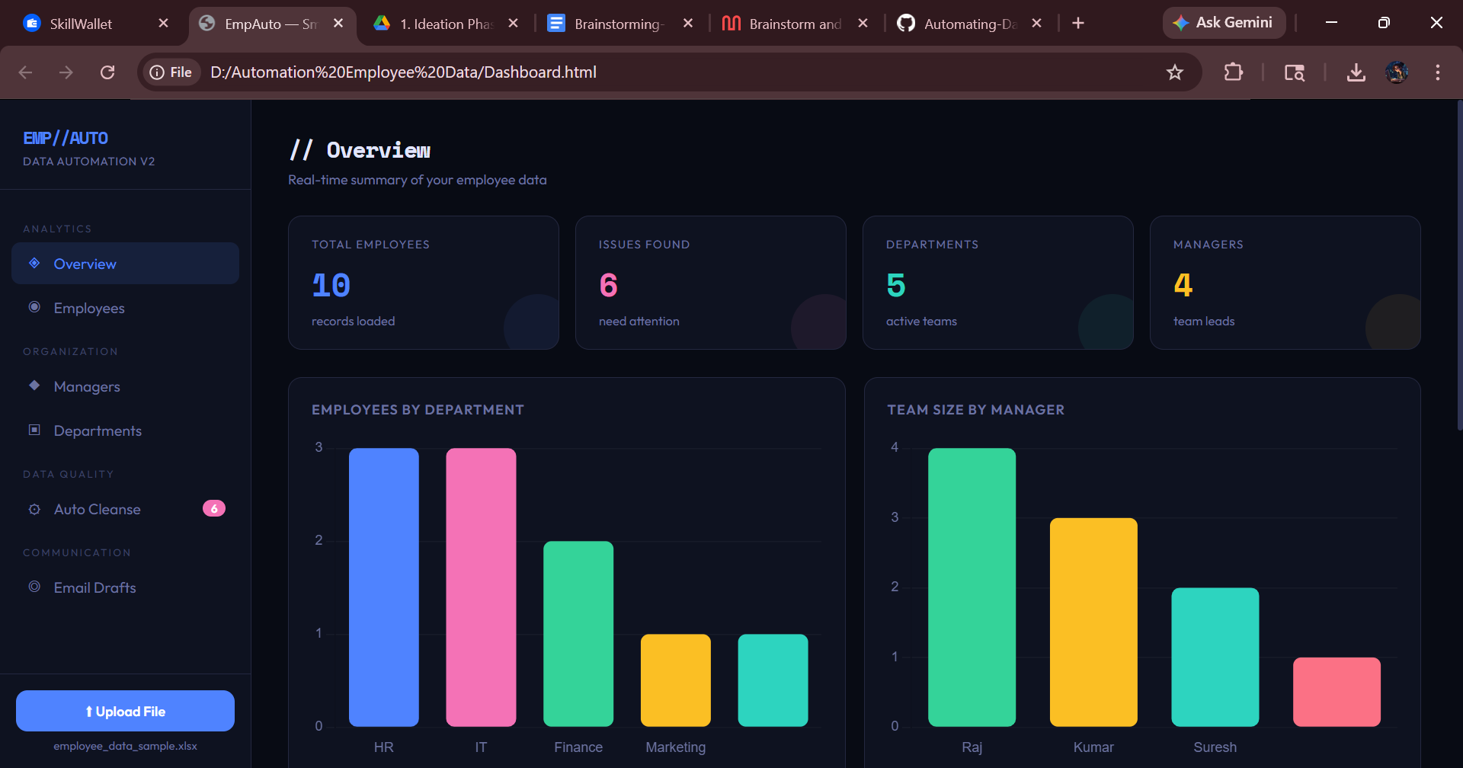

Employee Details or dataset View with search option
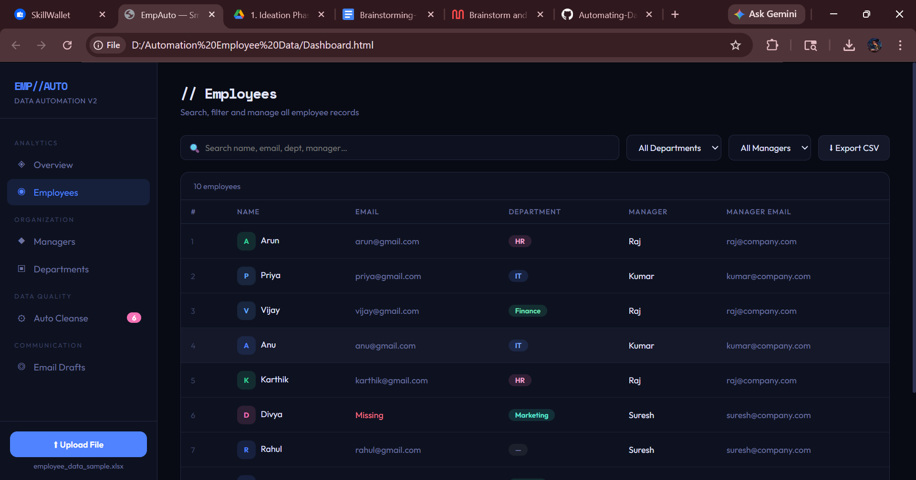

Managers Details in Data Set

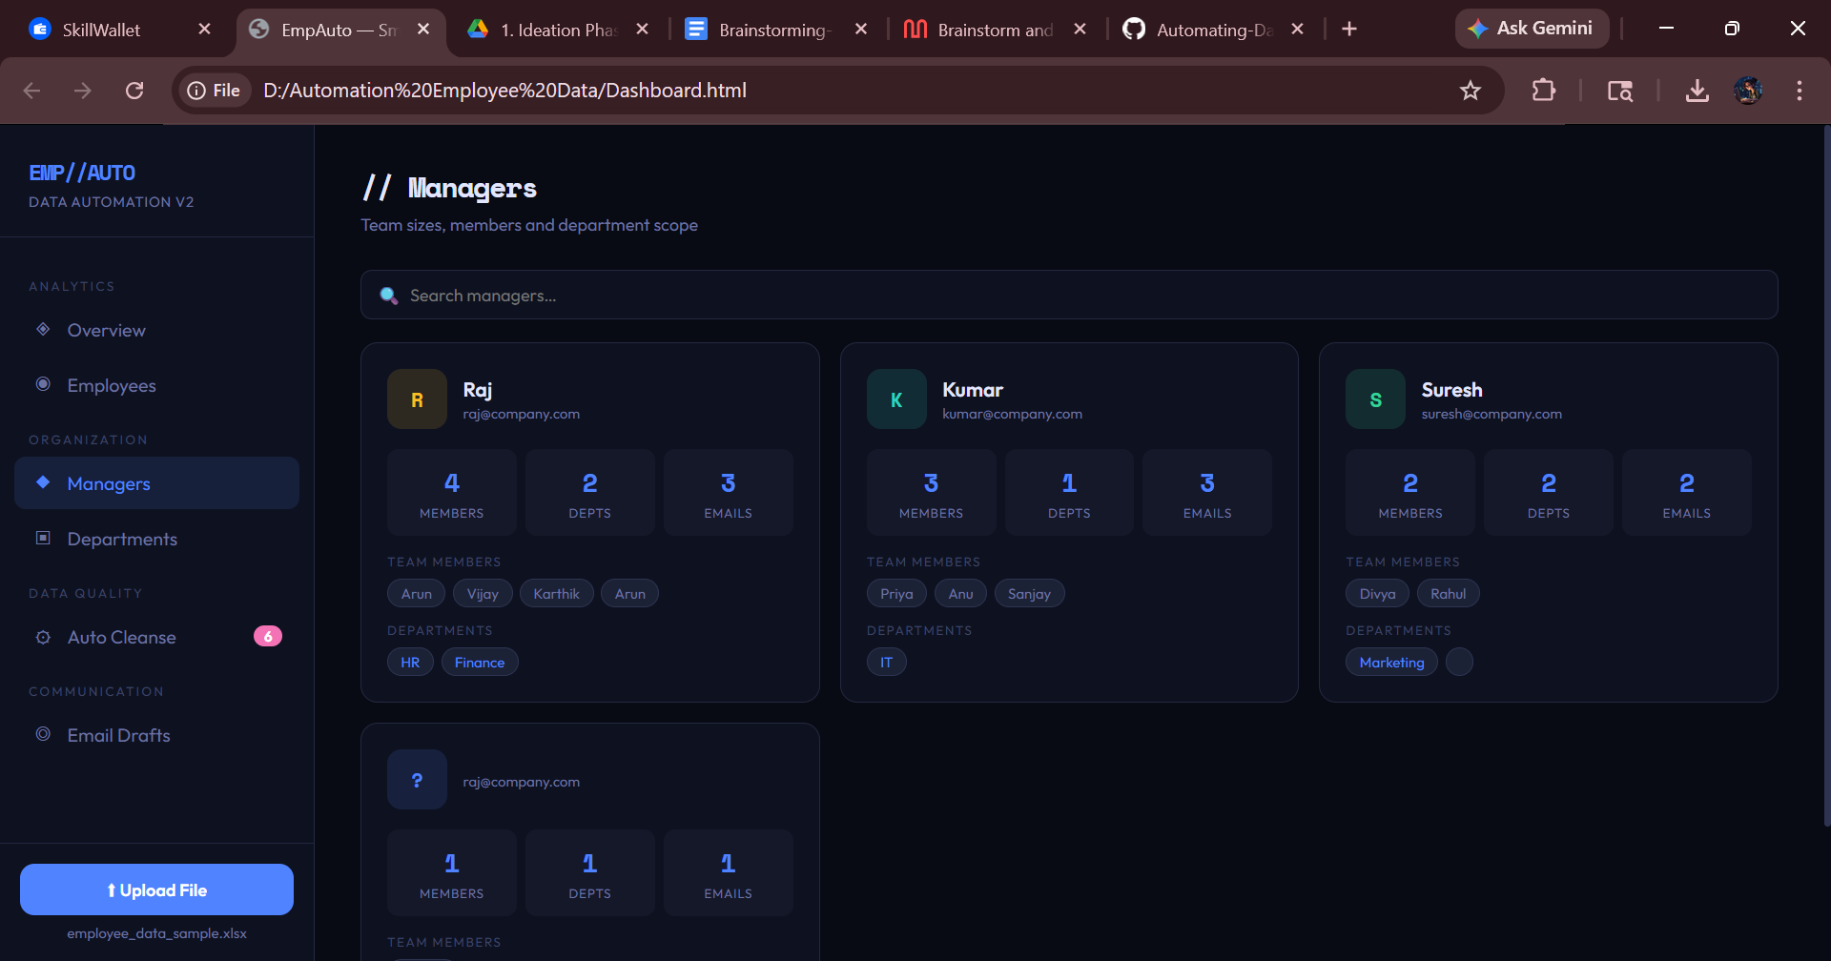

Departments Details
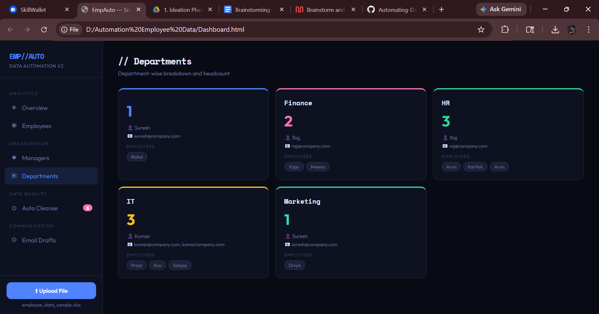

Auto Cleaning if the data contains missing values , duplicate values and so on..

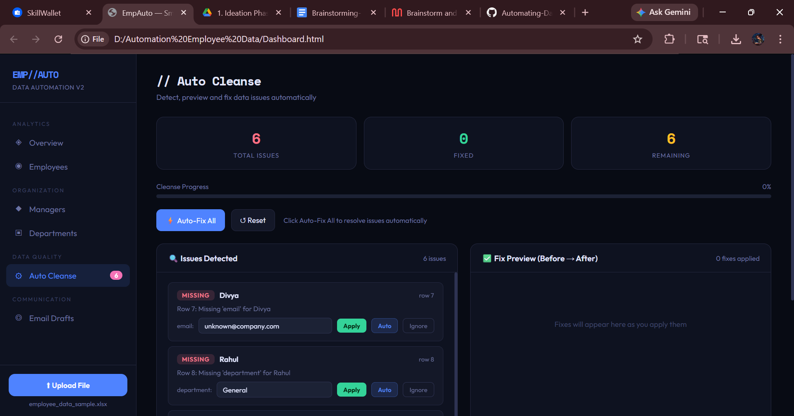

Automatically Email Drafts to corresponding persons

